Task 2:

Add 2 Collobrator

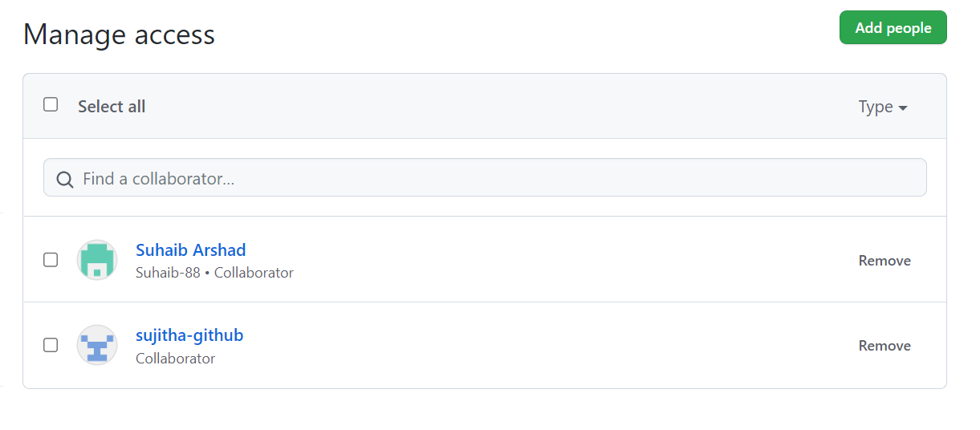

Proper open source file along with readme file and host git hub

